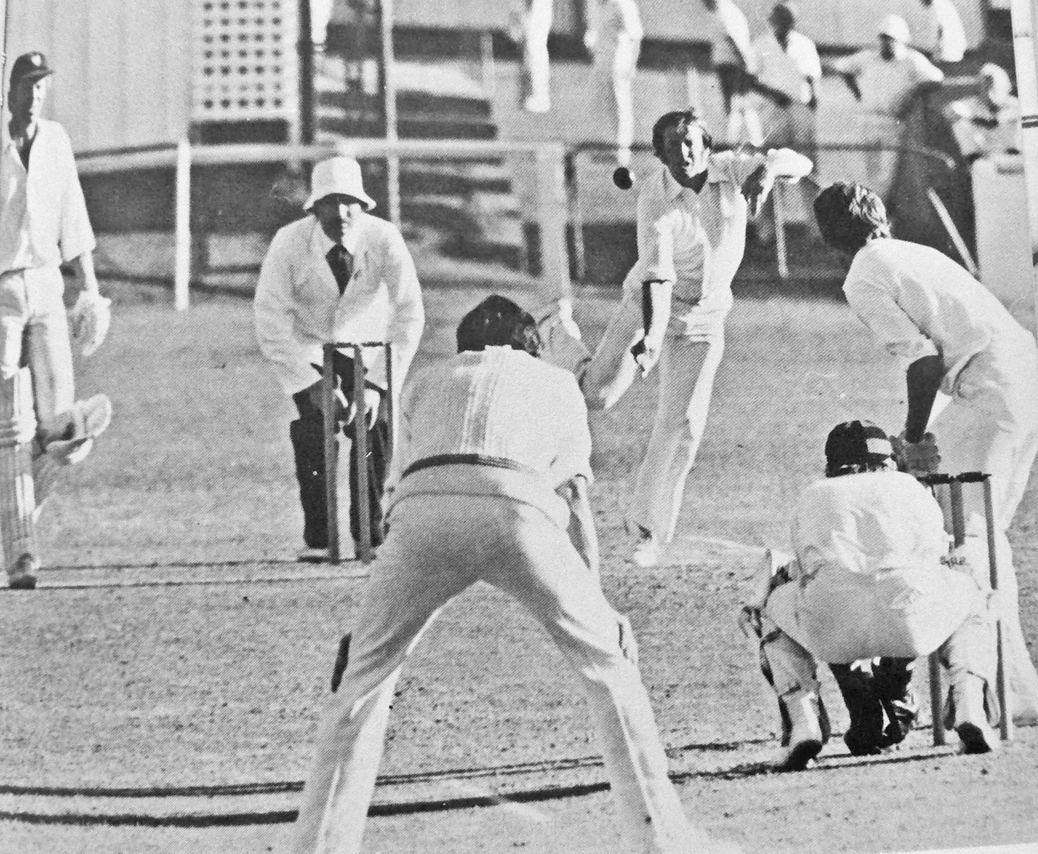

**Canterbury v Auckland 26 December 1977 Lancaster Park. David Stead bowling to JohnF Reid.**

**Maurice Ryan captain and wicket keeper**

**Canterbury 212 and 178/7declared Auckland 91 and 244 Canterbury won 55 runs**